Правительство Российской Федерации

ФЕДЕРАЛЬНОЕ ГОСУДАРСТВЕННОЕ АВТОНОМНОЕ

ОБРАЗОВАТЕЛЬНОЕ УЧРЕЖДЕНИЕ ВЫСШЕГО ОБРАЗОВАНИЯ

“НАЦИОНАЛЬНЫЙ ИССЛЕДОВАТЕЛЬСКИЙ УНИВЕРСИТЕТ ИТМО”

(Университет ИТМО)

Факультет Программной инженерии и компьютерной техники

ОТЧЕТ

О НАУЧНО-ИССЛЕДОВАТЕЛЬСКОЙ РАБОТЕ:

“Postex Website”

структура и правила оформления

в соответствии с требованиями ГОСТ 7.32–2021

Проект выполняли:

Суворов Денис P3221

Преподаватель:

Доц. факультета ПИиКТ Ефимчик Е.А

Санкт-Петербург

2021

# 2. Сontent

2. Сontent 2

3. Introduction 2

4. Analytical section 4

4.1 Idea 4

4.2 High-level description: 4

4.3 High-level description of parts: 4

4.4 Description of analogs 4

1.VK 4

2.Facebook 4

3.LinkedIn 4

4.5 Comparative table of analogues 5

5. Use cases section 6

5.1 List of actors 6

5.2 Use case diagram 7

5.3 Use case specification 7

6 DB Design 11

6.1 ER–диаграмма 11

6.4 Datalogical model 12

7. Interface design 13

7.1 List of interfaces 13

7.2 Interface diagram 19

8. Implementation of the project 20

8.1 Structure 21

8.2 Data Base 24

9.Сonclusion 25

# 3. Introduction

This is a social application that helps you make posts and share information. Also, it automatically make hashtags, which help users to search post which they want

The aim of the work is to create a web application. To achieve this goal, the following steps should be taken:

— formulate an application idea;

— consider analogues

— design use cases;

— design the database structure;

— design the application interface;

— select technology stack;

— develop the client side;

— write a server side to handle user requests;

— run the application and check its functionality.

# 

# 4. Analytical section

## 4.1 Idea

The idea is to create an app that will help you share information with others and will help you find posts that are interesting.

## 4.2 High-level description:

Target audience - people who like to lead discussions. The application allows you to see the posts of all users and rate them.

## 4.3 High-level description of parts:

The people who can interact with the interface are guests, registered users, and administrators. Users and administrators can create posts in their own profile. Any authorized user can like the post or find it through the search and go to the user's page. The user can watch the posts of other users.

The web application will work with a database that will store user authentication data, posts, likes, user hashtags.

## 4.4 Description of analogs

## 1.VK

A social networking site that provides functions such as chatting with friends, adding people you know as friends, sharing text, videos and pictures, understanding news, watching videos, etc.

## 2.Facebook

A social networking site where you can share photos, make posts, chat with friends, find friends of the opposite sex, etc.

## 3.LinkedIn

A special social networking site for IT workers, looking for potential workers, chatting with friends, sharing photos and videos and your achievements, etc

## 4.5 Comparative table of analogues

The table 1.0 shows a comparison of analogs.

Тable 1.0 - comparative table of analogues

|  |  |  |  |
| --- | --- | --- | --- |
| Categoty | Vk | Facebook | Linkedin |
| Social Application | + | + | + |
| Chat | + | + | + |
| Promote Strangers | + | + | + |
| Post | + | + | + |
| Share pictures and videos | + | + | + |
| Paid | - | - | - |

# 5. Use cases section

This section contains a list of actors, all use cases, actors and their interactions.

## 5.1 List of actors

Guest:

* See the information about website

* Register an account

* Can write feedback

User:

* Edit your own information

* Make posts

* Search posts by hashtag

* Can add hashtags for posts

* Like or dislike the searched post

* Do what guests can do

Administrator:

* Set and unset users as ADMIN

* Delete users

* Create random users

* Do what users and guests can do

## 5.2 Use case diagram

The figure 1.0 shows a use case diagram for the above actors.

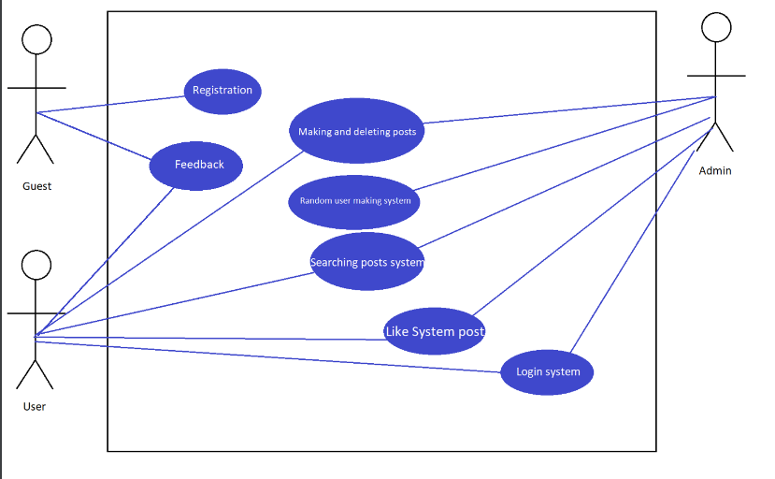

Figure 1 - Use case diagram

## 5.3 Use case specification

The figures 2.1 – 2.8 show the use cases that are available for the actors listed above.

Figure 2.1 Description of Use Cases

Figure 2.2 - BOM Portal Use Cases

Figure 2.3 - Register Use Cases

Figure 2.4 - Making and deletind posts Use Cases

Figure 2.5 – Searching Use Cases

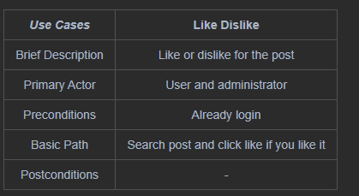

Figure 2.6 Like Dislike Use Cases

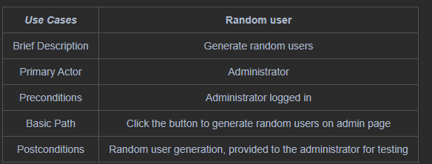

Figure 2.7 – Random user Use Cases

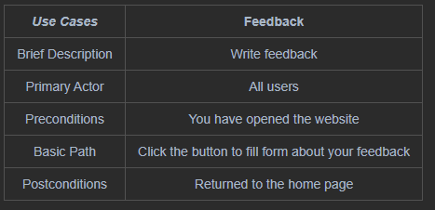

Figure 2.8 – Feedback Use Cases

# 6 DB Design

A database model is needed to indicate objects and relationships, constraints, rules, and operations to indicate the data semantics of a specific subject area. Generally, the database model establishes relationships between certain objects.

## 6.1 ER–диаграмма

ER– the diagram of the relationship between the entity is presented in figure 3.1

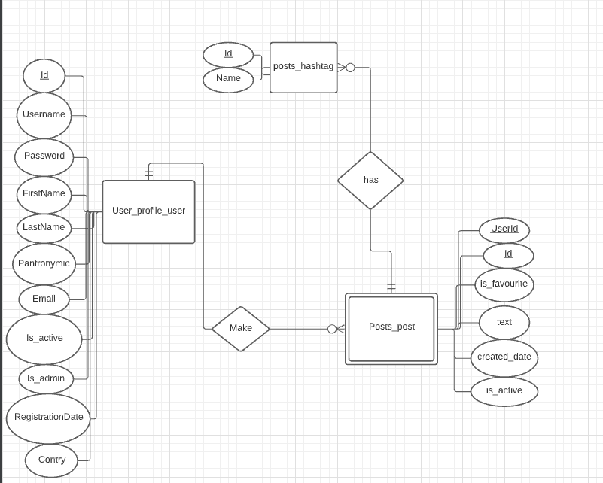

Figure 3.1 - ER diagram

## 

## 6.4 Datalogical model

Figure 3.2 - Datalogical model

# 7. Interface design

## 7.1 List of interfaces

**- Page of login**

Login and password form, remember form, the ability to recover the password

**- Page of registration**

Registration form with required fields of login and password mail

**- Page of Feedback**

Form for feedback (login mail and the text itself)

**- Page about website**

Site description page

**- Page of making and deleting posts**

If the user is authorized, then a page is available on which he can write a post (add a hashtag to it), a button to search for other posts

**- Page of searching posts by hashtags**

The field for entering keywords, if the desired post is not found, it will display that there is no such post

**- Page of searching posts**

Separate page for searching words in posts

**- Home page**

The home page of the site, from which you can use adding a post, viewing information about the site and sending feedback

**- Login admin page**

Login for admins

**- Admin page**

Where admins can delete/make users/posts

**- Profile page**

Info about user

Sketch drawings are presented on 4.0 - 4.9

Figure 4.0 - Home page

Figure 4.1 - Login page

Figure 4.2 - Page of feedback

Figure 4.3 - Page about website

Figure 4.4 - Page of making and deleting posts

Figure 4.5 - Registration page

Figure 4.6 - Page of searching by hashtag

Figure 4.7 - Admin log in

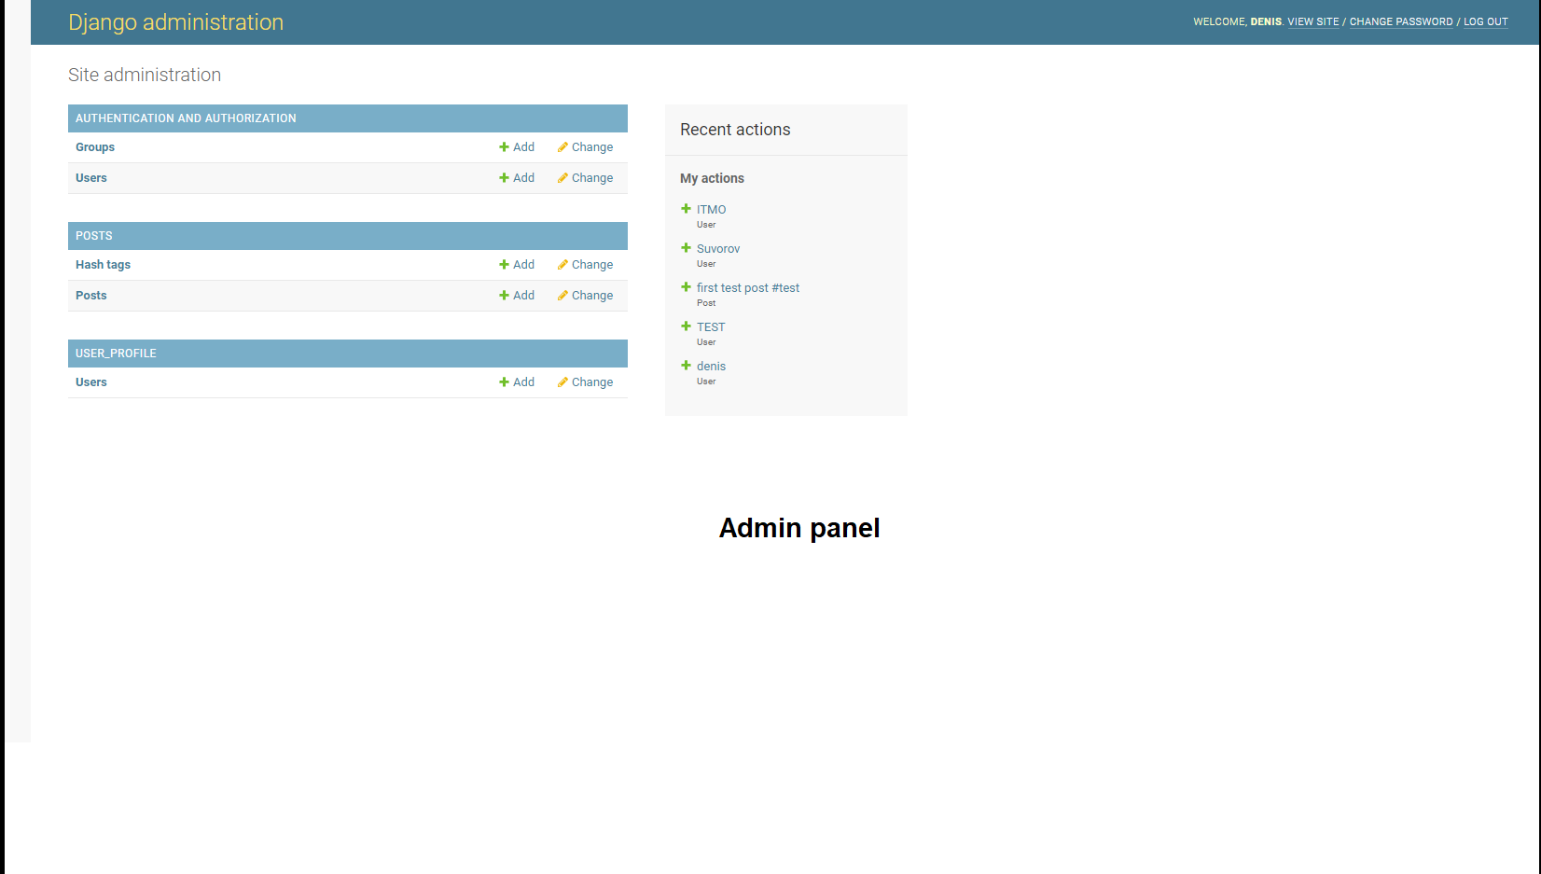

Figure 4.8 - Admin panel

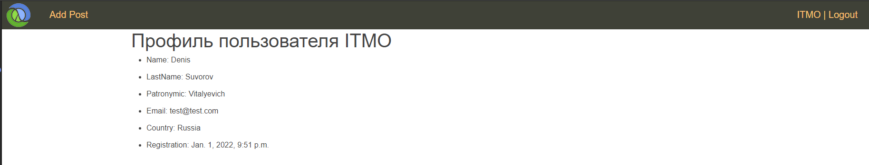

Figure 4.9 - Page about user

## 7.2 Interface diagram

The interface diagram is shown in the figure 5.0

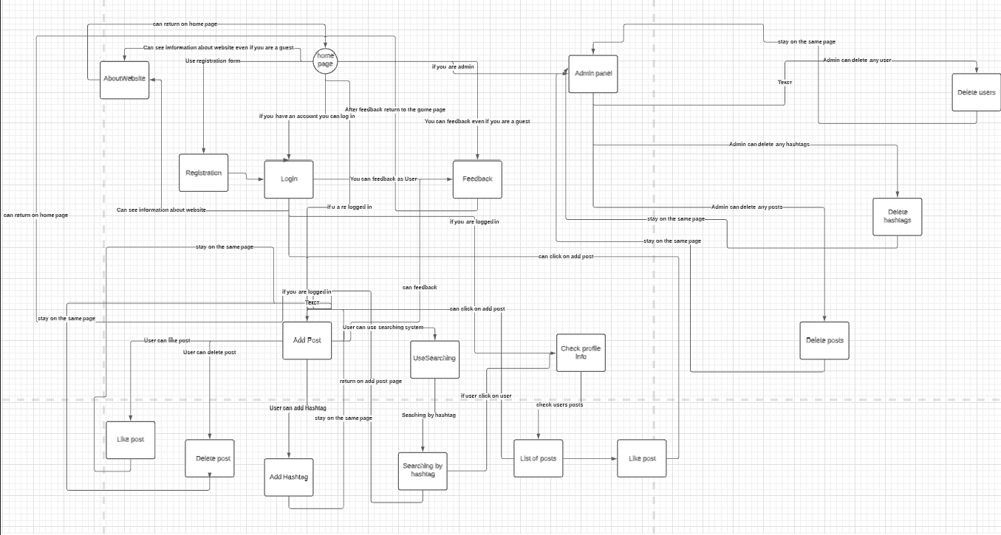

Figure 5.0 Interface diagram

# 8. Implementation of the project

To develop the application, I used the django framework and technologies like bootstrap, jquery and ajax.

Development was carried out through GIT.

https://github.com/Erkobrax/djangoProject.git

## 8.1 Structure

The figure 6.1 shows the structure of the application:

*Figure 6.1 – structure of app*

The figure 6.2 shows the manage.py. It starts my application

Figure 6.2 - manage.py

The figure 6.3 shows the settings.py. It contains the settings for the Django application

Figure 6.3 - settings.py

The figure 6.4 shows the static file. It contains ccs, js and img.

Figure 6.4 - static file

The figure 6.5 shows htlm pages.

Figure 6.5 - templates files

The figure 6.6 shows models.py in posts app.

Figure 6.6 models.py in posts

Views.py contains routes and view functions for each of the pages. By default, they implement a get method, where you need to send some forms, there is post. (Figure 6.7)

Figure 6.7 – views.py

More details can be found in my repository on github.

8.2 Data Base

In the screenshots(7.0-7.4) you can see an example of data on each of the database sheets.

Figure 7.0 - User

Figure 7.1 - Posts

Figure 7.2 Hashtags

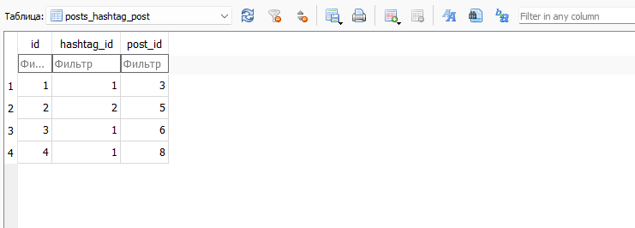

Figure 7.3 - Hashtag to which post

# 9.Сonclusion

As a result of my work, I created a web application. In the course of work, I came up with an idea, considered analogs, designed use cases, database structure, and use interfaces. I chose Python for implementation.

Upon completion of the work, I launched the application and checked its performance, which allows us to conclude that the project was successful.